COVER SHEET

Title of project:

The Annales School and the School Annals: Naas CBS 1913-23.

Name(s) of class / group of students / individual student submitting the project

Naas CBS fifth year history group.

Cillian Armstrong, Jack Bennett, Sam Curran, Ciaran Dillon, Conor Dowling, Matthew Drewitt, Daniel Faughnan, Ríain Fitzsimons, Conor Logue.

School roll number (this should be provided if possible)

61710C

School address (this must be provided even for projects submitted by a group of pupils or an individual pupil):

Meánscoil Iognáid Rís, Friary Road, Naas, County Kildare.

Class teacher’s name (this must be provided even for projects submitted by a group of pupils or an individual pupil):

Chris Lawlor

Contact phone number:

School: 045 866402 Teacher’s mobile: 087 9321737

Contact email address
lawlorcm@hotmail.com

The Annales School and the School Annals: Naas CBS 1913-23.
This project examines the history of the Irish revolutionary decade and how it affected our school, Naas Christian Brothers’ School (now Meánscoil Iognáid Rís but known at the time as the Moat School because the old school building stood beside a medieval motte, called simply ‘the Moat’ locally). Fortunately, much of this troubled period of time in County Kildare has been well documented, most recently in two books by James Durney: The Civil War in Kildare and The War of Independence in Kildare. Other books and articles also analyse the period at county level, but our study is unique as it takes a look at the history of this period from the perspective of the Christian Brothers Secondary School in Naas. We believe that history is evident everywhere including our locality, and our school is no exception to this fact.
Our perceptions and the way we think about history has changed over the years and there is now a new school of thought around the subject. This began in France with the Annales School of historians. The Annales School specialised in local history. In Ireland, we now refer to it as ‘New Cultural History’, and it explores the lives of ordinary people. Professor P. J. Corish put this very well when he referred to ‘the often secret life of the small folk who live among small things’. Corish’s book focused on the Irish Catholic community, but his words can apply to any community. Today, the study of local history often concentrates on the experiences of ordinary people in their local settings. Our school community is one example of such a local setting, and this is precisely what our project seeks to uncover.
The main source of information for this project was the ‘Annals of the Christian Brothers’, housed in Naas monastery. This is a primary source, and one that has not been used in any study of the period to date. We extend our thanks to the Naas Community of Christian Brothers for allowing us to use the Annals to research our project. Old issues of the Leinster Leader and Kildare Observer newspapers, and of Nucleus (an old school magazine) were also very important sources to us. We used secondary sources like Durney’s books to supplement the primary ones. Other printed secondary sources included From Poor House Road to the Fairy Flax… An illustrated history of Naas (Naas, 1990), To Spooner’s Lane and beyond (Naas, 1987) and Far from the Short Grass (Naas, 1999). A bibliography is given at the end.
However, it is our access to the Christian Brothers’ school Annals that has made it possible for us to focus in on one school community. The school within the town within the county is a microcosm within a microcosm within a microcosm of the nation. As the leading English historian H. P. R Finberg stated, ‘The microscope also has its uses. Within the nation there are smaller communities which have every right to be considered as distinct articulations of the national life’. Naas CBS is an example of what Finberg was talking about. However the school was not immune from outside influences, and our project also aims to look at the school through a wider series of events. Therefore, international events such as World War One, national events such as the struggle for Home Rule and local events like the arrest of the Leinster Leader editorial staff all contribute to the context in which the school operated at the time.
On the other hand, daily life went on in the school, the town and the local area during this decade too, and it must be realised that the major national political issues of history were not always the most important issues to the people at grassroots level. The Annals record school improvements and exam results alongside political events and wars. Prof. Raymond Gillespie and Dr. Gerard Moran suggest that: ‘People belonged to many different types of communities in which the common interests of the community were given conscious recognition’. Our local school is one such community. In fact, the school is at the heart of the local area of Naas as it often talked about by the people who live here, and we hope our project uncovers some of its previously hidden history.
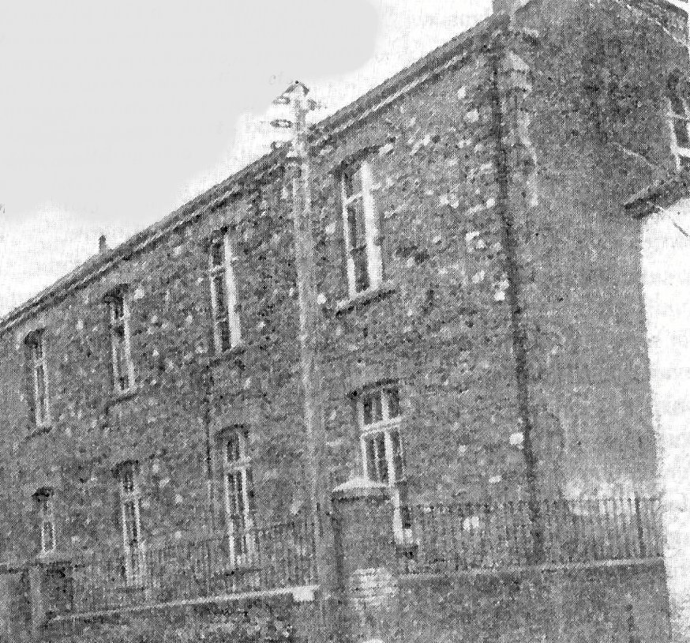
Fig 1: The Moat School c.1920.
The decade 1913-23 can be described as the Irish revolution. The first major event was the Dublin Lockout of 1913, but it had no direct impact on Naas. Though there was some poverty in the relatively rich town of Naas at the time, it was not industrialised and had not got a large working class population. There is no mention of the Lockout in the Annals of the Christian Brothers. However, the following year marked the beginning of the First World War. This was greeted with anticipation and enthusiasm throughout Europe. Some people warned that the war would be terrible, but they were not listened to as excitement grew and young men rushed to join the army. Many people on both sides thought that the war would be ‘all over by Christmas’, and John Redmond, the leader of the Irish Parliamentary Party called on all the members of the Irish Volunteers, a pro-Home Rule organisation, to join the army when he made a speech at Woodenbridge in County Wicklow.
Naas was also caught up in the wave of patriotism. The town had an army barracks and many Naas families had male members in the forces. The third battalion of the Royal Dublin Fusiliers was stationed at Naas barracks. On 6 August 1914 two hundred and eighty Royal Dublin Fusiliers marched to Naas railway station. The local Irish Volunteers escorted them and a band played as the soldiers paraded through the town. Flags and banners saying Naas Abú and Nás na Ríogh were prominently displayed and everyone sang ‘Auld Lang Syne’ as the train left the station. This was the first of many trains to leave Naas carrying soldiers on their way to the trenches at the front line. By June 1917 the number of men who had enlisted at Naas had grown to 22,611, and many of these came from the poorest areas of the town such as Back Lane and Rathasker Road. The town was much smaller a hundred years ago, with a population of three thousand, eight hundred and forty-two people according to the 1911 census, but many men came from the rural Kildare-West Wicklow region around the town as well. Given the big number of recruits, Redmond’s encouragement for nationalists to join up and the poor social status of many of the Naas soldiers, we can conclude that many ex-pupils of the Moat School joined up to fight for Home Rule in the belief that they would be rewarded with a parliament in Dublin after the war.
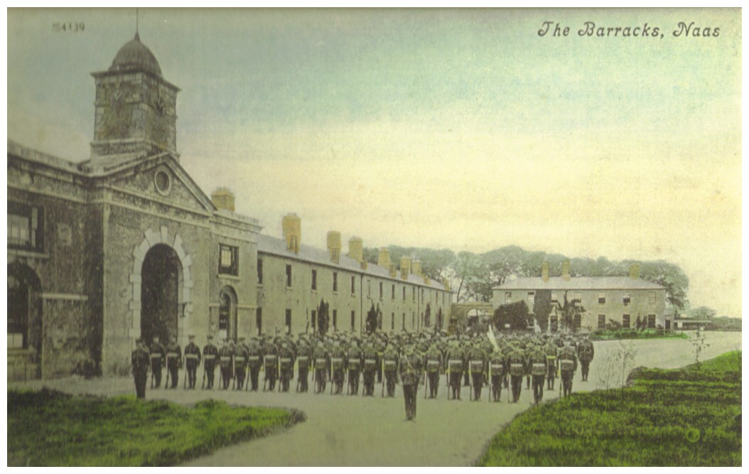
Fig 2: Naas Military Barracks c.1914.
Predictably there were many casualties. In total five hundred and sixty-seven Kildare men were killed in the Great War. Many of these, such as Private Maurice Joseph Grainger, son of Mortimer and Kate Grainger of Newtown, Naas, were past pupils of the Moat School. Grainger was killed in northern France and is buried in the British war cemetery at Vermelles, in the Pas de Calais region of France. In all, one hundred and ninety-three of the Royal Dublins from Naas barracks were killed and there were also many wounded, physically and mentally, who never recovered from the effects of the war.
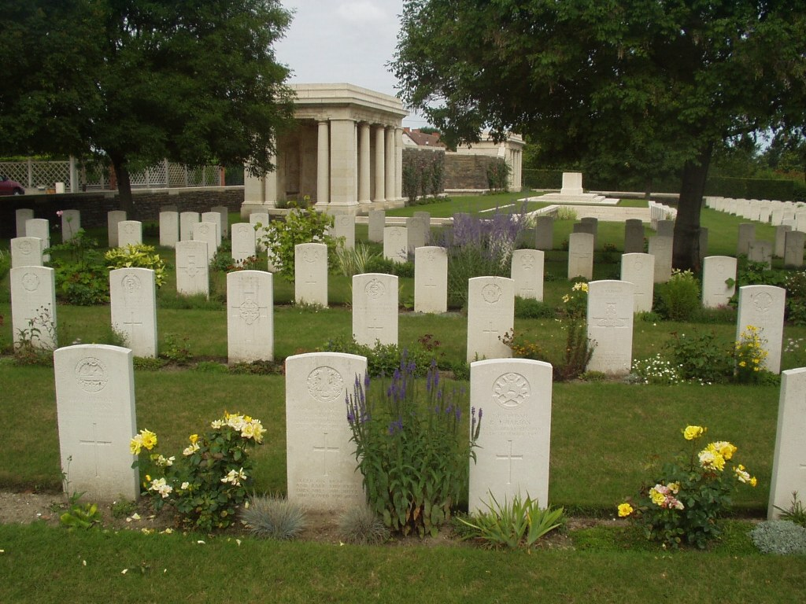
Fig. 3: Vermelles British War Cemetary.
The soldiers who did return were met with a completely different society. The events of the Easter Rising of 1916, and the aftermath of the shooting of the rebel leaders had sparked a renewed interest in nationalism in Ireland. Now, however, most Nationalists aspired to a republic rather than mere Home Rule. In Naas, Nationalists also followed this trend. The Leinster Leader indicated how feelings changed in the aftermath of the Easter Rising. In the week after the rising the editorials lacked any sympathy for the rebels as this extract shows:
Now that the rebellion has been crushed, we may in common express the hope that we may soon revert to that state of order which only peace, prosperity and mutual goodwill can give.
A series of events soon caused the Leader’s editorial to change its tone. These events were the arrests of Leinster Leader’s editor Michael O’Kelly and two of his staff, military raids on suspected Naas families like Pattersons, Whytes and Grehans and most importantly the execution of rebel leaders in Kilmainham Gaol. The sombre tone of the editorials now betrayed a shift in Nationalist opinions. On 13 May 1916 the following piece was published:
They have paid the penalties for their acts and over their graves we are silent; it will be for some historian of the future, removed from the passions and the prejudices of our day, to enquire into the motives and estimate the culpability at its true worth of these men.
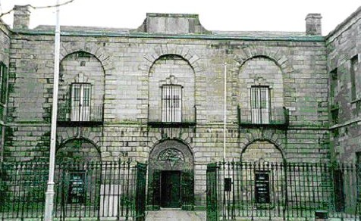
Fig 4: Kilmainham Gaol.
The opinions of the Republicans were evolving. The principal of the moat school, Br. A. A. (Austin) Kelleher was well aware of this fact. When Kelleher arrived in Naas in 1912, the primary objective of Naas Nationalists was Home Rule. When Kelleher departed Naas in 1918 the goal of Nationalists was no longer Home Rule – it had changed to the establishment of an Irish Republic. The Easter Rising and the execution of its leaders had changed the mood of the country. Prof. F. X. Martin made another significant relevant point when he wrote:
The leaders who emerged in 1916 and the subsequent years were largely past pupils of the Christians Brothers’ Schools… due recognition has not yet been given to the Irish Christian Brothers for their part in the Nationalist struggle, particularly for their unqualified support of the Gaelic Revival.
The education provided in Naas CBS, as in all Christian Brothers’ schools was very nationalistic, and young men, including many past pupils of the Moat School, were readying themselves for another fight after the failure of the rising and the deaths of its leaders. Support for the Sinn Fein party was increasing rapidly when Br. E. B. (Berchmans) O’Neill replaced Br. Kelleher as principal in 1918 and the Naas area was tense as war loomed closer. A more immediate danger also loomed – during this time there was an outbreak of influenza going around which lasted for ‘several weeks’. The Annals describe this illness as taking ‘plague form’. Large numbers of students were absent and those present were in cramped and crowded conditions which were ideal for spreading the disease, so Br. O’Neill decided to close the school two weeks into the epidemic. The school was closed for over two months and only reopened in mid-November, a week after the end of the Great War.
The enforced absence of the students meant that a lot of hard work had to be done after Christmas to catch up with their studies. Br. O’Neill noted in the Annals:
The power of resiliency stands very high in the character of the Irish and in none more than the sporting fraternity of Kildare… On the resumption of classes in January 1919, the pupils in all sections manifested a very active spirit of industry in their studies, which spirit was accompanied by a diligence and devotedness to school duty, worthy of high commendation.
The hard work was worth it for some of the students. Master Jones of Naas CBS was awarded a scholarship to UCD in 1919 due to his excellent exam results. Another UCD scholarship was awarded to Master Quinlan in 1920, and in the same year a former pupil and fellow classmate, William Tyndall joined the religious order, the Carmelites. As well as nationalistic education, religious education was very strong in the Christian Brothers’ schools and Tyndall was one of many boys from Naas CBS who opted to join the clergy during this period.
As principal, Br. O’Neill oversaw improvements to the school and the grounds. O’Neill’s first improvements came about in 1918-1921 when the pupils and teachers saw their playground altered from a ‘veritable death trap’ to a better standard of schoolyard with the addition of ‘hundreds of tons of rubble’. Around this time new toilets were also added. Despite the noisy construction work and any other distractions, Br. O’Neill stated that ‘school work went to the satisfaction of all concerned’. These improvements were funded by contributions from the students, which had increased due to bigger numbers attending the school especially from the ‘surrounding rural parts’. Perhaps then, as now, free education was not completely free; voluntary contributions have a long history in our school.
Also during the years 1919-1921, as the improvements were being carried out in the school, the War of Independence raged on. The IRA randomly attacked the British forces and the RIC with the use of guerrilla warfare. Nationally, IRA figureheads such as Dan Breen, Tom Barry, and Michael Collins led the resistance against the Black and Tans and the Auxiliaries. The Auxiliaries raided the town of Naas and vandalised the meeting place of the local Sinn Fein organisation. They took volunteer uniforms and scrawled messages on the front of the town hall. These read ‘God Save The King’ and ‘Up the RIC’. It was reported in the Kildare Observer newspaper of 19 March 1921 that these messages were removed while the paint was still wet.
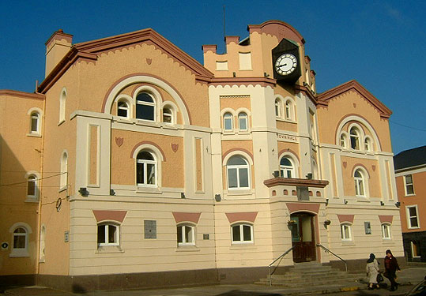
Fig 5: Naas Town Hall.
With these dangers surrounding them, the Christian Brothers couldn’t express their nationalism openly in their Annals, because the Auxiliaries or the Black and Tans could seize them in a raid. The Annals are very muted on the War of Independence, and what is recorded seems to have been written when the conflict was over. The Annals state:
Located as Naas is midway between the Curragh and the capital the citizens had much to fear following the advent of the Auxiliaries and the Black and Tans in the years following the First World War and the acceptance of the [Versailles] treaty. The North Kildare brigade as well as that of West Wicklow found little scope for manoeuvring their manpower in the national interests, as every call from headquarters was closely watched by the army of occupation, whose base may be said to be at their very doors. Harassed on all sides, they found themselves isolated and utterly unable to lend any substantial aid to their countrymen in Dublin, while the road to the sterner battle centres in the south was always vigilantly guarded. The daily movements of the Black and Tans on the main thoroughfare between Dublin and the South aroused a lively interest, if not a fair modicum of fear, among the inhabitants of the peaceful plains of North Kildare.
Before Naas was bypassed, the main roads to the South and Southeast met in the centre of the town. This meant that the town saw many troop movements on the roads to Limerick, Cork, Kerry, Carlow, Kilkenny and Waterford between 1919-1921. The tone and the language used in the above extract from the Annals shows that the Naas Christian Brothers were very biased in favour of the IRA and the ‘national interests’. The War of Independence concluded with the signing of the Anglo Irish Treaty on 6 December 1921. This treaty was found to be unacceptable by some elements of the IRA, the Dáil, and the country in general, but a majority of people favoured the agreement. Following this treaty Naas Nationalists were divided into pro-Treatyites and anti-Treatyites, reflecting the wider situation across Ireland.
The British pulled out after the treaty, and the last detachment of Royal Dublin Fusiliers left Naas in early February 1922. According to the Kildare Observer of 11 February, they paraded through Naas singing ‘The wearing of the green’ the night before. The newspaper also stated that the final few Black and Tans left Naas the day after. The Tans marched through Main Street holding a Union Jack, singing ‘Goodbye’ and ‘Auld Lang Syne’. The departure of British forces from Naas leaving no one in control, led to the pro and anti-Treaty IRA confronting each other. Irish Nationalists were divided in the Civil War that followed, and many Naas families and past-pupils of the CBS were involved in the split. In April 1922, Michael O’Kelly, Thomas Williams, and Laurence Callaghan were all arrested in Naas and were imprisoned by Free State forces in the Curragh camp. Michael Collins spoke at a Free State rally on 16 April in Naas and was an honoured guest at a banquet at the town hall later that day. In July of that year, Naas was occupied by Free State forces, who took up several vantage points in the town. They were there to counter the threat that from anti-Treaty forces in the Blessington-Ballymore Eustace area, but Naas was not attacked and no action was taken.
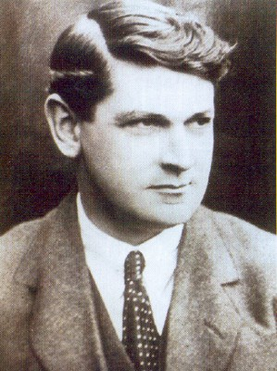
Fig 6: Michael Collins.
The Christian Brothers were in another tricky situation where they could not show favour to one side or the other. We do not know if the brothers in Naas were divided, because the Annals stay silent on the issue and concentrate on the boys’ education. The Annals are very reticent about the Civil War, and the records were again written after the end of the struggle. The very fleeting mention of both the War of Independence and the Civil War in the Annals is different to the picture of County Kildare painted in James Durney’s books on these wars in County Kildare. This may be explained by the fact that the brothers saw danger in keeping written records, and certainly didn’t want to record the names of those involved in their Annals, in case the British or, later, either the pro or anti-Treaty side could have accessed them to get information. The Civil War is only mentioned in very general terms in this extract:
The civil war had thrown its dark shadows over the landscape. Very many prominent citizens were to be found identifying themselves with the policies or principles of the contending sides. The friction engendered thereby was reflected among the pupils and so it was obviously felt that a prudent attitude had to be adopted, and a firm, if impartial, line of discipline to be pursued in the best interests of all concerned. The spirit of neutrality that characterized the attitude of the Community towards these delicate and dangerous political movements in these troublesome times won the admiration of the people as a whole. Soon all North Kildare had resumed its characteristic quiet. The good name of the school grew in the popular mind and the annual collection in aid of the community and school showed a progressively upward trend.
The anti-Treaty IRA commander Liam Lynch, a nephew of an ex-principal of Naas CBS Br. Martin Lynch, was killed in April 1923. This signalled the beginning of the end of the Civil War. A ceasefire was announced and came into operation on 24 May. By the end of that month, Naas and its people, including the Christian Brothers and their students, were effectively citizens of the Irish Free State.
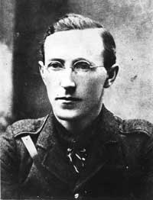
Fig 7: Liam Lynch.
Predictably, the Free State wanted to introduce a much more Nationalistic education and began a series of educational reforms in 1923. In 1924 the old intermediate exam system ended in a year when the Naas school had been most successful. Eight students passed at junior grade, five at intermediate and five at senior. On top of these good results five students passed the matriculation examination and three were awarded National University scholarships. Also that year Naas CBS were offered the three County Council scholarships. These went to Joseph Tyrell, Michael Purcell and Vincent Noone.
When Professor Eoin McNeill was appointed Minister for Education one of his first goals was to change the old curriculum. McNeill followed the Christian Brothers’ lead because they had been involved in nationalistic teaching in the town of Naas and elsewhere for a long time. The high educational standards of Naas Christian Brothers in the Moat School and the nationalistic type of education they provided meant that the nuns in the neighbouring town of Kilcullen consulted them in 1923. Now that they were in a Free State, the nuns were separating from their English motherhouse in Bolton and aligning themselves with the new Irish government’s Department of Education. These Passionist nuns were deciding on their curriculum and how they should teach it, and the fact that the Christian Brothers were consulted showed they were highly regarded locally and within the new state. According to the annals of the monastery:
Within a year the Kilcullen pupils were forging ahead with an Irish-Ireland curriculum and they were very soon grappling successfully with the various subjects through the medium of Irish.
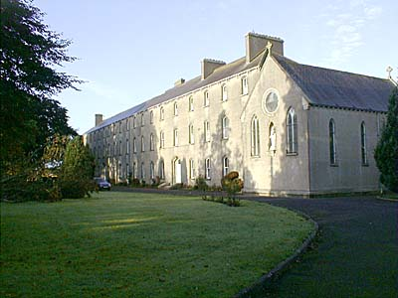
Fig 8: Cross and Passion School, Kilcullen.
According to the Annals, many of the boys in the Moat School had sisters boarding in Kilcullen School. Names listed in the annals include many of the leading middle class Catholic families in and around Naas – shopkeepers, farmers, professional people and property owners – at this time. These include Purcell, Tyrell, McDermott, Broe, Dowling, Foynes, Byrne, Kinsella, Coffey, Jennings, Malone, Boyle, Tyndall and Gorry. This could be a sign of the direction the school was heading. Now the school was concentrating on getting wealthier middle class students through their exams. The ideals of Edmund Rice and educating the Catholic poor were lost in a new exam system, where the Christian Brothers would become religious and educational pillars of the new Irish state. The brothers were among the main beneficiaries of the Irish revolution of 1913-23. During that time they had changed from a nationalistic, anti-establishment order to a respected order leading the way in Irish education. The Annals of the Naas Christian Brothers community reflect this change.
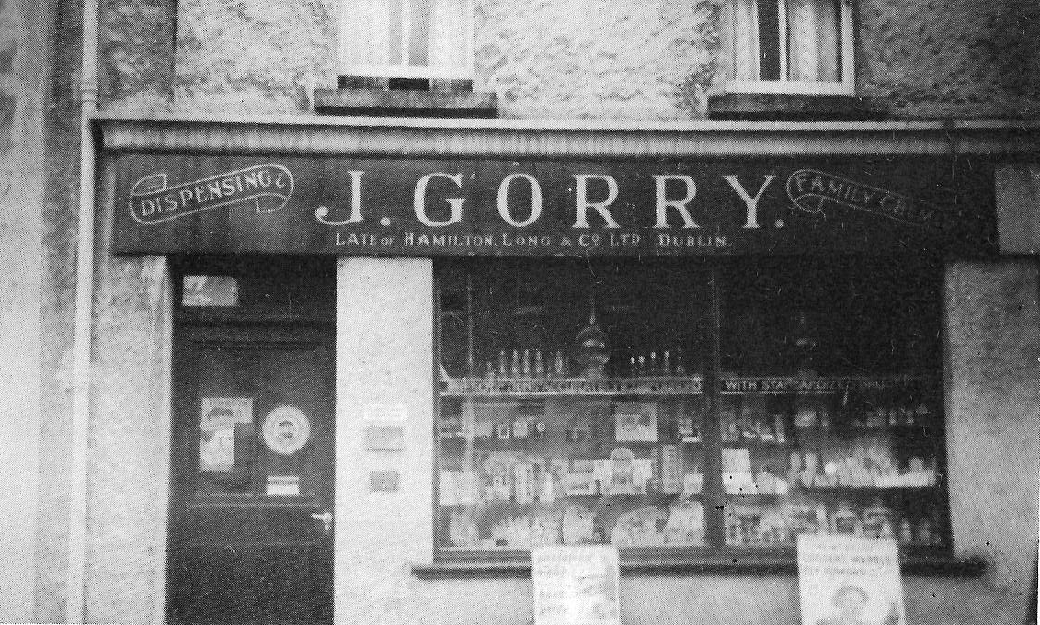
Fig 9: Gorry’s pharmacy in Naas.
This project has traced the history of the Naas area and its Moat School from 1913-23. It has used many sources to do this, but the unique aspect of our study is that access to the Annals of the Naas Christian Brothers meant we could examine the period from the perspective of the order and the school. Events that changed Ireland’s history like the First World War, the War of Independence and the Civil War are recorded alongside the ordinary events in the everyday life of the school like exam results, improvements to the playground and the closure of the school because of the flu epidemic. The school Annals allow us to use the Annales School approach to local history, looking at ‘history from below’. This period changed a lot in Irish history and we were lucky to have access to a local primary source that meant we could follow the progress of the Christian Brothers in the Moat School from nationalistic opponents of the educational system to instigators of a new system in a changed Ireland.
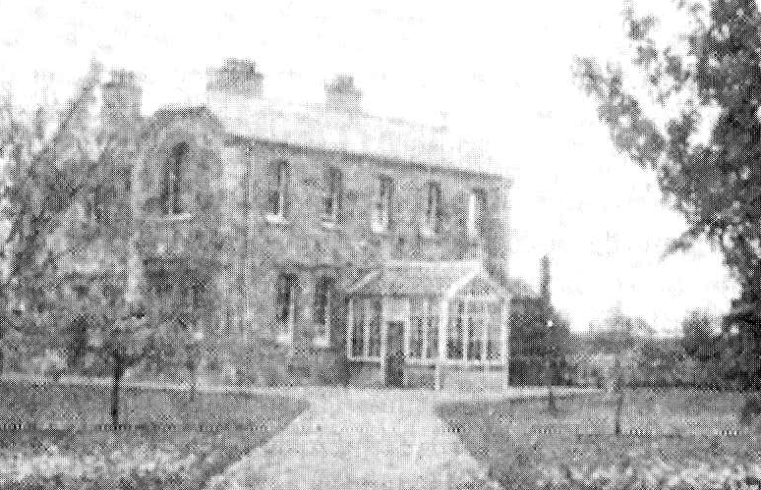
Fig 10: The monastery, Naas. Opened in 1903, it saw all the events mentioned in this project and now houses the Annals of the Naas Christian Brothers.

BIBLIOGRAPHY

PRIMARY SOURCES

Manuscript sources
Christian Brothers Monastery, Naas.
Annals of the Naas Christian Brothers, vol. 1

Newspapers
Leinster Leader 1912-24
Kildare Observer 1912-24

SECONDARY SOURCES

Published sources
Beckett, J. C., The Making of Modern Ireland1603-1923, (London, 1973).
Collins, M. E., An Outline of Modern Irish History 1850-1951, (Dublin, 1974).
Corish, Patrick J., The Catholic Community in the seventeenth and eighteenth centuries (Dublin, 1981).
Dooley, Terence, ‘IRA activity in Kildare during the War of Independence’ in William Nolan and Thomas McGrath (eds), Kildare history and society (Dublin, 2006), pp 625-656.
Durney, James, Far from the Short Grass: Kildare Men in Two World Wars (Naas, 1999).
_____________, The Civil War in Kildare (Cork, 2011)
_____________, The War of Independence in Kildare (Cork, 2013).
Foster, R. F., Modern Ireland 1600-1972, (London, 1989).
Gillespie, Raymond and Moran, Gerard (eds.), ‘A Various Country’: Essays in Mayo History (Westport, 1987).
Johnstone, Tom, Orange, green and khaki (Dublin, 1992).
Lawlor, Chris, ‘The development and present state of local Irish historiography’ in Journal of the West Wicklow Historical Society, 5 (Naas, 2009), pp 95-102.
Lyons, F. S. L., Ireland Since the Famine (4th Impression, Glasgow, 1976).
Martin F. X. and Moody T. W., The Course of Irish History, (Dublin, 2001).
McManus, Liam, To Spooner’s Lane and Beyond: Naas G.A.A. 1887-1987 (Naas, 1987).
Naas CBS Nucleus School Magazines 1972-74
Naas Local History Group, Nás na Ríogh…From Poorhouse Road to the Fairy Flax: An Illustrated History of Naas (Naas, 1990).
Small, Stephen, An Irish Century 1845-1945: From the Famine to World War II, (Dublin, 1998).
Electronic sources
http://treaty.nationalarchives.ie/the-treaty/ (accessed 19/3/2014)
http://www.cbslk.ie/media/files/Edmund%20Rice1(1).ppt (accessed 19/3/2014).
http://www.cwgc.org/find-war-dead/casualty/251603/GRAINGER,%20MAURICE%20JOSEPH (accessed 26/3/2014)
http://www.inchicore.info/photos/view/33 (accessed 2/4/2014)
http://www.michaelcollinscentre.com/(accessed 26/3/2014)
http://www.naaspm.ie/ (accessed 2/4/2014)
http://www.nli.ie/1916/pdf/11.pdf (accessed 18/3/2014)
http://www.rootschat.com/forum/index.php?PHPSESSID=d0m5qjjv59u10mkgki6t7d4rs4&topic=153750.45 (accessed 2.4.2014)
http://www.rsfcork.com/liamlynch.htm (accessed 26/3/2014)
https://www.blinkboxbooks.com/#!/book/9781407097213/ireland-in-the-20th-century (accessed 29/3/2014)

